**Source 1** was written by Henry Knighton, a man who lived through the Black Death and described its immediate effects in his book *History of England* from the 14th century.

*“****Sheep and cattle went wandering … and there was no one to go and drive or gather them … many crops perished in the fields for want of someone to gather them.***

***But the peasants were so lifted up and obstinate that they would not listen to the king's command, but if anyone wished to have them he had to give them what they wanted, and either lose his fruit and crops, or satisfy the wishes of the workmen.***

***After the pestilence, many buildings, great and small, fell into ruins in every city for lack of inhabitants, likewise many villages and hamlets became desolate … it was probable that many such villages would never be inhabited.”***

**Source 2** a painting depicting the Flagellants, created 1549.

[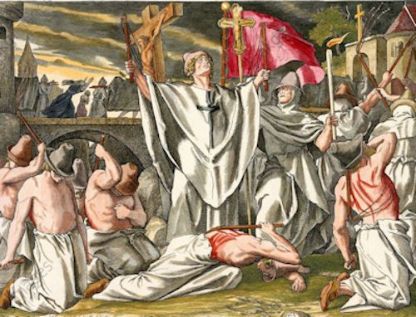](https://www.google.com/url?sa=i&rct=j&q=&esrc=s&source=images&cd=&cad=rja&uact=8&ved=2ahUKEwiv6ZDIyMDdAhUHOrwKHVXuAuEQjRx6BAgBEAU&url=https://www.pinterest.com/pin/588212401301389061/&psig=AOvVaw1etX7Mwx5RqvuQ1w7yV6ru&ust=1537223121236317)

**Source 3** a 2008 graph showing world population growth throughout history. Historians have different opinions on exactly how many people died as a result of the Black Death.

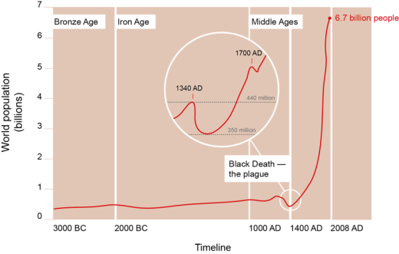

**Source 4** An excerpt from a book of special studies of the Black Death as a turning point in history, 2006, written by author, broadcaster and lecturer Professor Tom Beaumont James of Winchester University.

**The vast majority of the population at the time of the Black Death was rural peasants who suffered the highest mortality and in so doing, became much more expensive and choosy about where they worked, and how they related to lords. Weakened communities provided the opportunity in the century and a half after the plague for landlords to clear lands and enclose them for sheep, so that Sir Thomas More, writing soon after 1500, saw the countryside as overrun and consumed by sheep. People certainly expected and obtained higher wages even in the church, whose authority was challenged by many. Recruitment to the parish clergy fell and monastic houses never recovered. …. Perhaps Cardinal Gasquet was right when he noted long ago that the plague led to the emergence for the first time of a middle class (who chatter and challenge authority) funded by accumulating the wealth of those who had died. Thus the old medieval tripartite division of society into those who fought (the nobility and knights), those who prayed (the churchmen) and those who laboured (the peasants) was never the same again.**